Refatorando arquivos nos diretórios

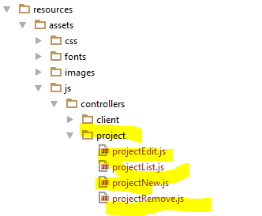

Colocando controllers na App.blade

<**script src="**{{ asset(**'build/js/controllers/project/projectList.js'**) }}**"**></**script**>  
<**script src="**{{ asset(**'build/js/controllers/project/projectNew.js'**) }}**"**></**script**>  
<**script src="**{{ asset(**'build/js/controllers/project/projectEdit.js'**) }}**"**></**script**>  
<**script src="**{{ asset(**'build/js/controllers/project/projectRemove.js'**) }}**"**></**script**>

Criando o Service

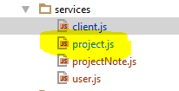

Adicionando na app.blade.php

*<!-- SERVICES !-->*<**script src="**{{ asset(**'build/js/services/client.js'**) }}**"**></**script**>  
<**script src="**{{ asset(**'build/js/services/project.js'**) }}**"**></**script**>  
<**script src="**{{ asset(**'build/js/services/projectNote.js'**) }}**"**></**script**>  
<**script src="**{{ asset(**'build/js/services/user.js'**) }}**"**></**script**>

Criando Views de Project

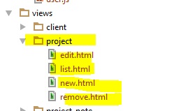

Corrigindo o Transforms de Project

**class** ProjectTransformer **extends** TransformerAbstract  
{  
 **protected $defaultIncludes** = [**'members'**, **'client'**];  
  
 **public function** transform(Project $project)  
 {  
 **return** [  
 **'project_id'** => $project->**id**,  
 **'client_id'** => $project->**client_id**,  
 **'owner_id'** => $project->**owner_id**,  
 **'name'** => $project->**name**,  
 **'description'** => $project->**description**,  
 **'progress'** => $project->**progress**,  
 **'status'** => $project->**status**,  
 **'due_date'** => $project->**due_date** ];  
 }  
  
 **public function** includeMembers(Project $project)  
 {  
 **return** $this->collection($project->**members**, **new** ProjectMemberTransformer());  
 }  
  
  
 **public function** includeClient(Project $model)  
 {  
 **return** $this->item($model->**client**, **new** ClientTransformer());  
 }  
}

Controller projectList.js

**angular**.module(**'app.controllers'**)  
 .controller(**'ProjectListController'**, [  
 **'$scope'**, **'$routeParams'**, **'Project'**, **function** ($scope, $routeParams, Project) {  
 $scope.**projects** = Project.query();  
 }]);

Service Project.js

**angular**.module(**'app.services'**)  
 .service(**'Project'**, [**'$resource'**, **'appConfig'**, **function** ($resource, appConfig) {  
 **return** $resource(appConfig.**baseUrl** + **'/project/:id'**,{**id**: **'@id'**}, {  
 **update**: {**method**: **'PUT'** }  
 });  
 }]);

View/Project/list.html

<**div class="container-fluid"**>  
 <**div class="row"**>  
 <**div class="col-md-8 col-md-offset-2"**>  
 <**div class="panel panel-default"**>  
 <**div class="panel-heading"**>Listagem de projetos</**div**>  
 <**div class="panel-body"**>  
 <**table class="table"**>  
 <**thead**>  
 <**tr**>  
 <**th**>#</**th**>  
 <**th**>Name</**th**>  
 <**th**>Client</**th**>  
 <**th**>Progress</**th**>  
 <**th**>Status</**th**>  
 <**th**>Due date</**th**>  
 <**th**>Ações</**th**>  
  
 </**tr**>  
 </**thead**>  
 *<!-- {{o.client.data.name}} para acessar a data dos transformes-->* <**tbody**>  
 <**tr ng-repeat="o in projects"**>  
 <**td**>{{o.id}}</**td**>  
 <**td**>{{o.name}}</**td**>  
 <**td**>{{o.client.data.name}}</**td**>  
 <**td**>{{o.progress}}</**td**>  
 <**td**>{{o.status}}</**td**>  
 <**td**>{{o.due_date}}</**td**>  
 <**td**>  
 <**a ng-href="#/projects/{{o.id}}/edit"**>Editar</**a**>  
 <**a ng-href="#/projects/{{o.id}}/remove"**>Excluir</**a**> </**td**>  
 </**tr**>  
 </**tbody**>  
 </**table**>  
 </**div**>  
 </**div**>  
 </**div**>  
 </**div**>  
</**div**>